**Data Center Recent Launches**

1. **Blackwell-Powered Systems**: In June 2024, Nvidia unveiled a range of systems powered by the Blackwell architecture, featuring Grace CPUs and Nvidia networking infrastructure. These systems are designed to build AI factories and data centers.
2. **Next-Gen GPUs for Data Centers**: In December 2024, Nvidia introduced its latest line of GPUs specifically designed for data centers. These GPUs offer enhanced Tensor Cores, increased memory bandwidth, improved energy efficiency, advanced cooling systems, and scalability for multi-GPU configurations.
3. **Blackwell Ultra and Vera Rubin GPUs**: Nvidia confirmed that these GPUs are on track for release in 2025 and 2026. These GPUs are expected to bring significant advancements in AI performance and data processing.

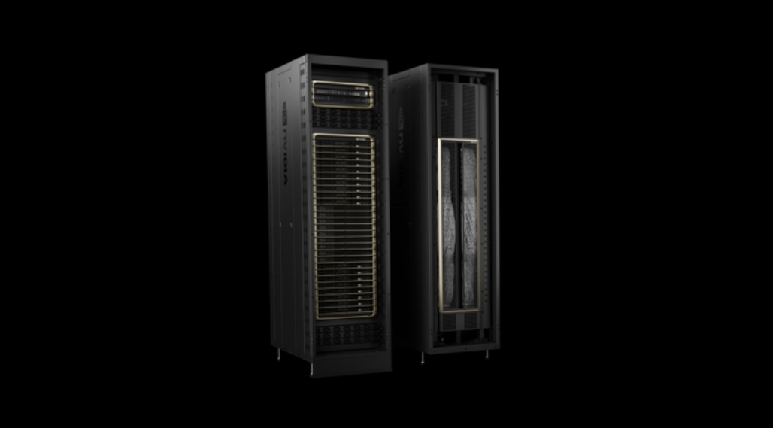

**Blackwell-Powered Systems**

**Blackwell Ultra and Vera Rubin GPUs**